Photograph from Govisumber, No. 27
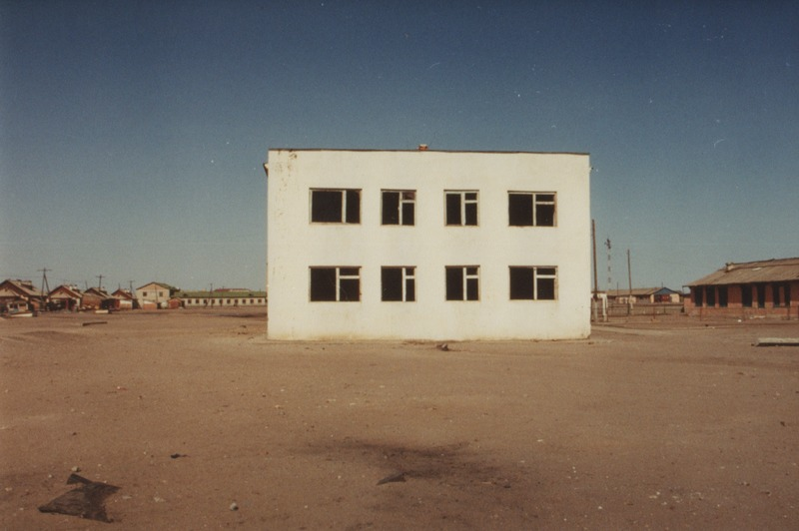

identifier
eee07ef9-d18e-4b75-9bc9-c49d81d479a4

creator
Sneath, David

type
Image

coverage
Govisumber aimag
Mongolia

description

publisher

source
scanned from a photographic print held in the archives of the Mongolia and Inner Asia Studies Unit, University of Cambridge

rights

subject
settlements

date
1995

language

format
image/png

contributor

original filename
sneath-govisumber_27.png

relation

extent
1776x1182 px
3.2MiB

