Castrating camels
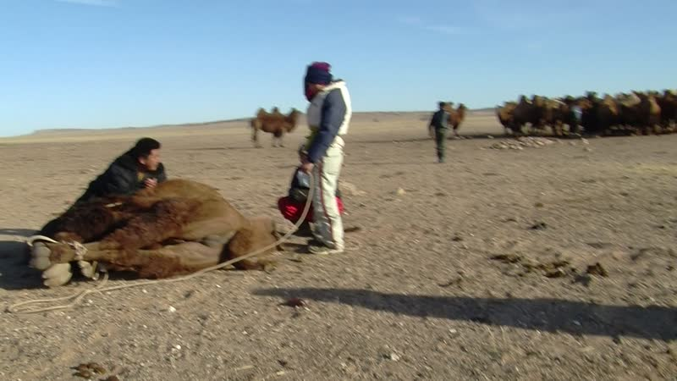

identifier
f02aaa79-4124-4e4f-92cf-3c95a24170fa

creator
Thrift, Eric

type
Moving Image

coverage
Mongolia
Dornogovi aimag
Sainshand sum

description
This series of audiovisual recordings shows Sodnomtsog castrating camels at Noogii and Enkhee's place. He is helped out by Sükhee and monks from Khamar Monastery.

publisher

source

rights

subject
Pastoralism Videos
Castrating Camels
Sodnomtsog

date
2012-11-17

language

modified
2018-03-02 09:36:46

table of contents
time | clip | description
0:00:00 | 300G0243 01
0:13:53 | 300G0243 02
0:27:47 | 300G0243 03
0:41:40 | 300G0243 04

