Setting up a corral at San's place
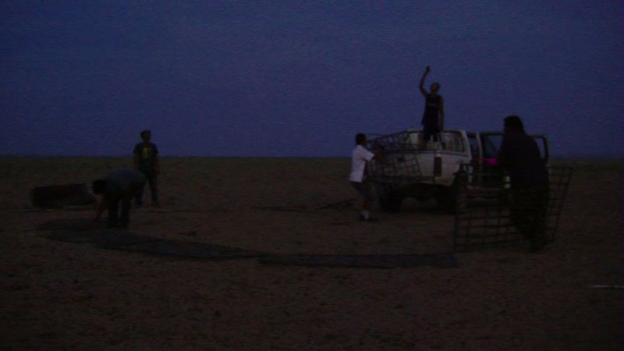

identifier
f3b488cf-a5eb-4979-a1ba-80d8d2cd296a

creator
Thrift, Eric

type
Moving Image

coverage
Mongolia

description
The recordings in this series depict a visit with Sodnomtsog to his uncle's autumn camp, where the men (Sodnomtsog, San, and Odkhüü) set up a corral for the sheep and goats.

publisher

source

rights

subject
Pastoralism Videos
Building Corral
San-Saraa
Dornogovi-Ulaanbadrakh

date
2012-09-07

language

format
inode/directory

modified
2018-03-02 09:37:44

original filename
PastoralismVideos--2012-09-07--BuildingCorral--San-Saraa--Dornogovi-Ulaanbadrakh.vclips

table of contents
time | clip | description
0:00:00 | 300G0115 01 | View of the central square in Sainshand and a poster on the wall of the Dornogovi aimag museum, advertising the schedule for the upcoming festival at Khamar Monastery.
0:00:26 | 300G0116 01 | View of the central square in Sainshand and a poster on the wall of the Dornogovi aimag museum, advertising the schedule for the upcoming festival at Khamar Monastery.
0:09:03 | 300G0118 01 | Setting up a corral for the sheep and goats. Sodnomtsog and a hired hand gather up metal fencing units and place them in the back of Sodnomtsog's pickup truck.
0:13:58 | 300G0119 01 | Attaching a rope to Sodnomtsog's truck and his uncle's Russian jeep, so as to tow the jeep (which will not start).
0:15:10 | 300G0120 01 | Setting up a corral for the sheep and goats.
0:22:43 | 300G0121 01 | Setting up a corral for the sheep and goats.

