30181
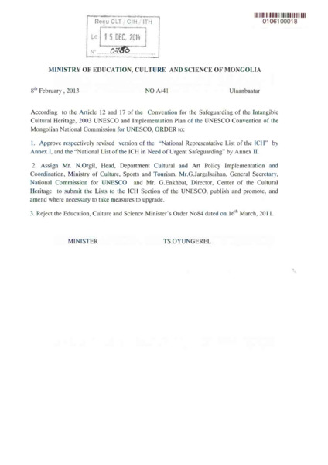

identifier
f47140f0-6768-41f0-b10a-3513ff76f058

creator
Mongolia

type
Text

coverage
Mongolia

description
ICH Inventory. UNESCO List of Intangible Cultural Heritage in Need of Urgent Safeguarding, Nomination file No. 01061, “Coaxing ritual for camels” (Mongolia).

publisher

source

rights

subject

date

language
English

original filename
30181.pdf

extent
1.4 MiB

format
application/pdf

modified
2016-02-24 14:45:30

