Caroline Humphrey - Buryatia photos - No. 2-01
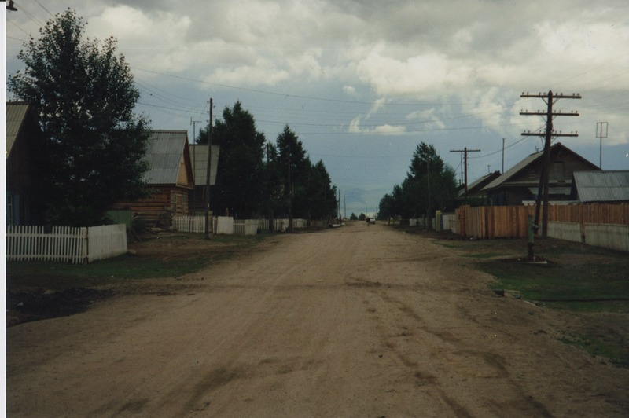

identifier
f55d4c08-b34c-4da1-8bf8-7d3d705c17d8

creator
Humphrey, Caroline

type
Image

coverage
Bayangol
Khilgana
Karl Marx Collective
Buryatia
USSR

description
Looking West.

publisher

source
Scanned from a print held in the archives of the Mongolia and Inner Asia Studies Unit, University of Cambridge.

rights

subject

date
1993

language

contributor

original filename
Humphrey-Buryatia-photos-2-01.png

relation

extent
3.2MiB
1799x1196 px

format
image/png

