2215149. Tsam
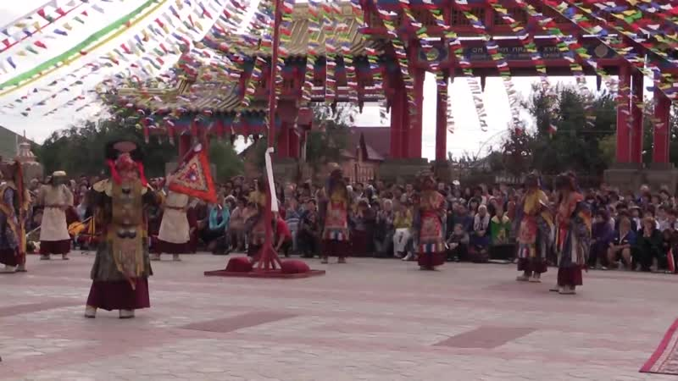

identifier
f7c71586-b42b-49d9-8646-0a185bba028f

creator
Kalmyk Cultural Heritage Documentation Project

type
Moving Image

coverage
Kalmykia
Russia

description

publisher
University of Cambridge

source
<http://www.kalmykheritage.socanth.cam.ac.uk>

rights
Copyright Kalmyk Cultural Heritage Documentation Project. Licensed under a Creative Commons BY-NC-ND Unported license.

subject
Buddhism
Kalmyks

date
2017-04-25 00:17:02

language

original filename
2215392.mp4

extent
4.6 GiB
12852.600000

format
video/mp4

modified
2017-05-29 12:12:47

remote embed url
http://sms.cam.ac.uk/media/2215149/embed

public
FALSE

