Vitafit factory tour image - 67ohq752obbhglsjouladl8b4o l
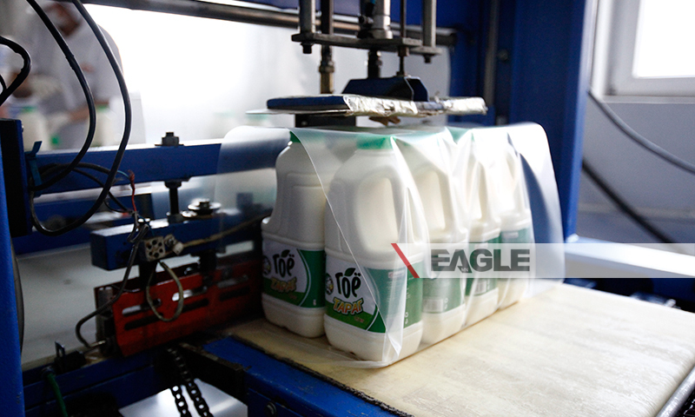

identifier
f85222d7-0d57-43a6-8cfd-3affc8ed66b9

creator

type
Image

coverage
Mongolia

description
Goyo yogurt factory tour image published by Eagle.mn.

publisher

source

rights

subject
Mongolia
dairy
nationalism
social media

date
2014

language
Vitafit factory tour image - Vitafit factory tour image - 67ohq752obbhglsjouladl8b4o l

format
image/jpeg

original filename
67ohq752obbhglsjouladl8b4o_l.jpg

extent
316.7 KiB
800x480 px

modified
2014-03-24 18:29:22

