Photograph from Inner Mongolia, No. 05
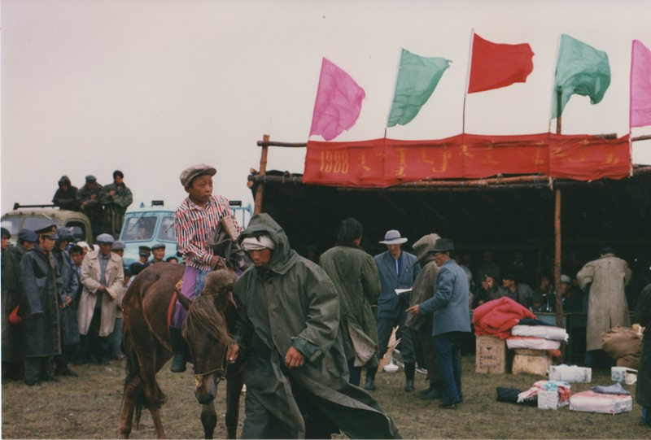

identifier
faab7a91-eb46-4f01-a598-eae9a46d1b06

creator
Sneath, David

type
Image

coverage
Inner Mongolia
PRC

description
Horse-races (local Naadam)

publisher

source
Scanned from a photographic print held in the archives of the Mongolia and Inner Asia Studies Unit, University of Cambridge.

rights

subject
horse-races

date
ca. 1988

language

original filename
sneath-inner-mongolia-1980s.png_05.png

relation

extent
2.9 MiB
1747x1182 px

contributor

format
image/png

modified
2017-05-25 10:59:56

