Photograph from Inner Mongolia, No. 08
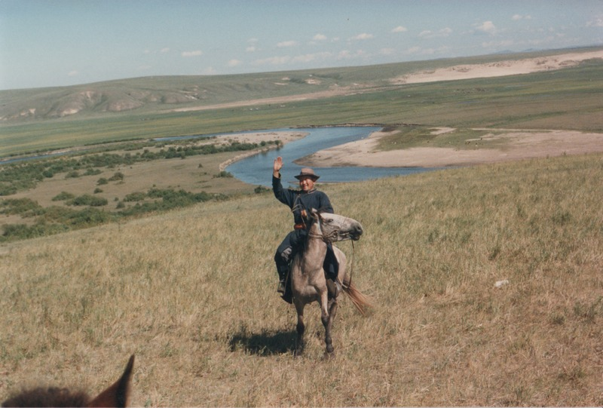

identifier
fc1fbd41-703d-470b-a0a6-45bd99b01eea

creator
Sneath, David

type
Image

coverage
Inner Mongolia
PRC

description

publisher

source
Scanned from a photographic print held in the archives of the Mongolia and Inner Asia Studies Unit, University of Cambridge.

rights

subject
herder households

date
ca. 1988

language

original filename
sneath-inner-mongolia-1980s.png_08.png

relation

extent
3.3 MiB
1747x1182 px

contributor

format
image/png

modified
2017-05-25 11:02:16

