Photographs from Barguzin, No. 06
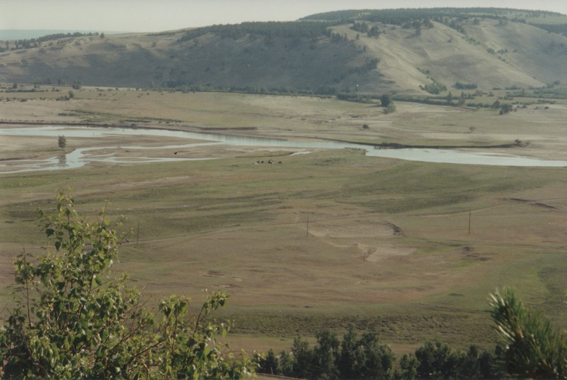

identifier
fc423fdf-3b55-44c7-9dbc-98f15c83e45d

creator
Gomboev, Bair

type
Image

coverage
Barguzin
Burtyatia
Russian Federation

description
Summer pastures of Argada selsoviet, South region. Very poor, sandy pastures.

date
1993-07

language

format
image/png

modified
2017-05-25 02:01:22

original filename
bair-batbuyan-photos-06.png

source
Scanned from a photographic print held in the archives of the Mongolia and Inner Asia Studies Unit, University of Cambridge

extent
3.3 MiB
1777x1191 px

subject
rangeland

