11655
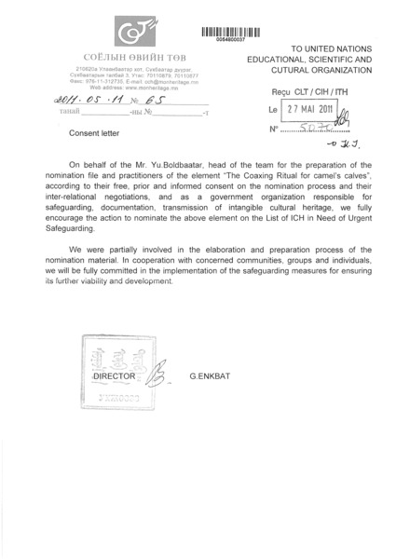

identifier
fdfa8bdd-6726-4331-90a3-d5e179afc283

creator

type
Text

coverage
Mongolia

description
Consent of Communities. UNESCO List of Intangible Cultural Heritage in Need of Urgent Safeguarding, Nomination file No. 00548, “Coaxing ritual for camels” (Mongolia).

publisher

source

rights

subject

date

language
English
Mongolian

original filename
11655.pdf

extent
155.5 KiB

format
application/pdf

modified
2012-12-05 01:59:48

