&quot;Оргил хүнс&quot; хятад тараг савлав уу
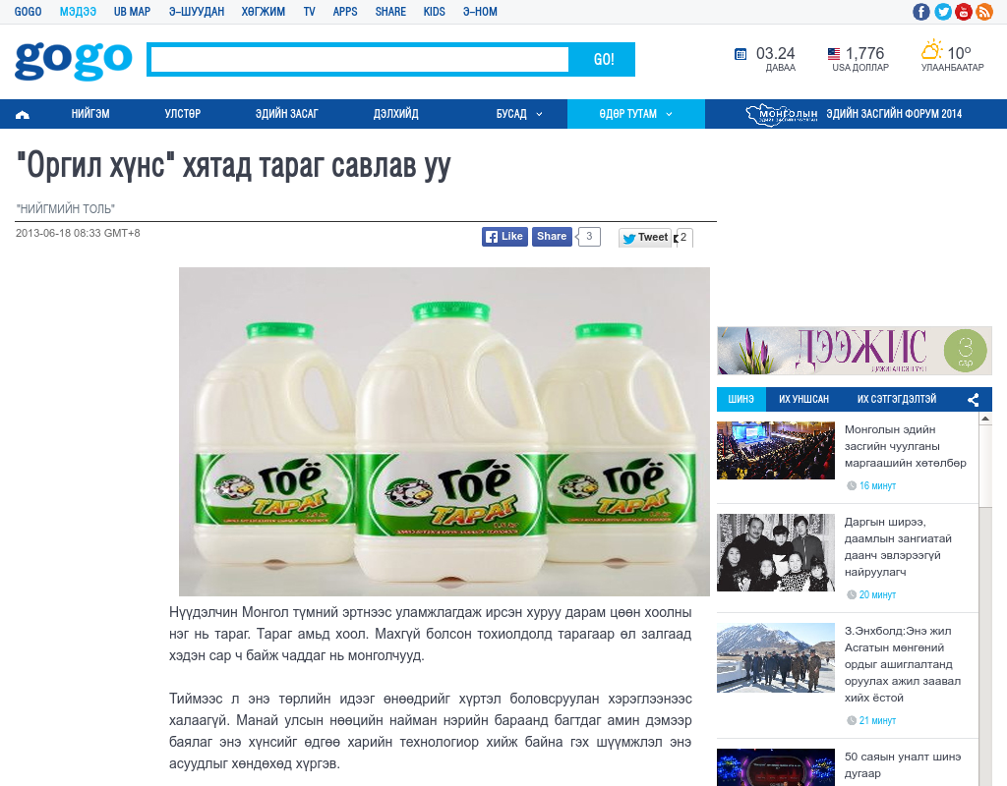

identifier
ff0f004f-94f8-4fbd-b8b4-6ee172717e90

creator

type
Text

coverage
Mongolia

description

publisher

source
http://news.gogo.mn/r/124544

rights

subject
Mongolia
dairy
nationalism
social media

date
24 Mar 2014 14:52:00

language
Mongolian

format
text/plain

modified
2018-01-11 14:12:43

original filename
gogo.mn.Khyatad_tarag_savlav_uu.url

extent
28.0 B

