Photographs from Barguzin, No. 07
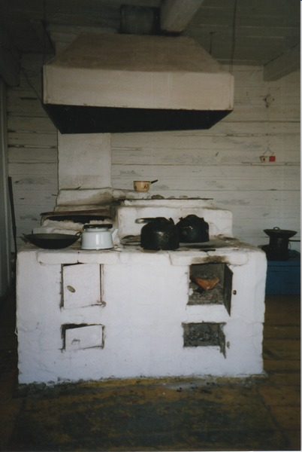

identifier
ffba59ee-cce9-4a35-861c-ae3fede6a710

creator
Gomboev, Bair

type
Image

coverage
Barguzin
Burtyatia
Russian Federation

description
Cooking stove in house in summer camp, Argada.

date
1993-07

language

format
image/png

modified
2017-05-25 02:02:34

original filename
bair-batbuyan-photos-07.png

source
Scanned from a photographic print held in the archives of the Mongolia and Inner Asia Studies Unit, University of Cambridge

extent
3.1 MiB
1191x1777 px

subject
kitchen
pastoral camps

